Exercise: Classes & Unit Testing on Classes
Submit your solutions in the SoftUni judge system at:
https://alpha.judge.softuni.org/contests/classes-and-attributes-exercise/2769

Classes

Rectangle
Write a class Rectangle for a rectangle object. It needs to have a width (Number), height (Number), and color (String) properties, which are set from the constructor, and a calcArea() method, that calculates and returns the rectangle’s area.

Input
The constructor function will receive valid parameters.

Output
The calcArea() method should return a number.
Submit the class definition as is, without wrapping it in any function.

Examples
Sample Input | Output
let rect = new Rectangle(4, 5, 'Red');  console.log(rect.width);  console.log(rect.height);  console.log(rect.color);  console.log(rect.calcArea()); | 4  5  Red  20

Data Class
Write a class Request that holds data about an HTTP request. It has the following properties:
- method (String)
- uri (String)
- version (String)
- message (String)
- response (String)
- fulfilled (Boolean)
The first four properties (method, uri, version, message) are set through the constructor, in the listed order. The response property is initialized to undefined and the fulfilled property is initially set to false.

Constraints
- The constructor of your class will receive valid parameters.
- Submit the class definition as is, without wrapping it in any function.

Examples
Sample Input | Resulting object
let myData = new Request('GET', 'http://google.com', 'HTTP/1.1', '')  console.log(myData); | Request {  method: 'GET',  uri: 'http://google.com',  version: 'HTTP/1.1',  message: '',  response: undefined,  fulfilled: false  }

Hints
Using ES6 syntax, a class can be defined similar to a function, using the class keyword:
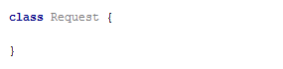
At this point, the class can already be instantiated, but it won’t hold anything useful, since it doesn’t have a constructor. A constructor is a function that initializes the object’s context and attaches values to it. It is defined with the keyword constructor inside the body of the class definition and it follows the syntax of regular JS functions - it can take arguments and execute logic. Any variables we want to be attached to the instance must be prefixed with this identifier:
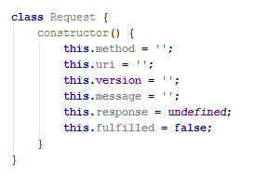
The description mentions some of the properties need to be set via the constructor - this means the constructor must receive them as parameters. We modify it to take four named parameters that we then assign to the local variables:
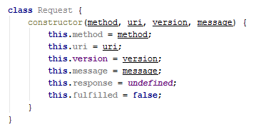
Note the input parameters have the same names as the instance variables - this isn’t necessary, but it’s easier to read. There will be no name collision because this identifier tells the interpreter to look for a variable in a different context, so this.method is not the same as the method.
Our class is complete and can be submitted to Judge.

Tickets
Write a program that manages a database of tickets. A ticket has a destination, a price, and a status. Your program will receive two arguments - the first is an array of strings for ticket descriptions and the second is a string, representing a sorting criterion. The ticket descriptions have the following format:
<destinationName>|<price>|<status>
Store each ticket and at the end of execution return a sorted summary of all tickets, sorted by either destination, price, or status, depending on the second parameter that your program received. Always sort in ascending order (the default behavior for alphabetical sort). If two tickets compare the same, use order of appearance. See the examples for more information.

Input
Your program will receive two parameters - an array of strings and a single string.

Output
Return a sorted array of all the tickets that were registered.

Examples
Sample Input | Output Array
['Philadelphia|94.20|available',  'New York City|95.99|available',  'New York City|95.99|sold',  'Boston|126.20|departed'],  'destination' | [ Ticket { destination: 'Boston',  price: 126.20,  status: 'departed' },  Ticket { destination: 'New York City',  price: 95.99,  status: 'available' },  Ticket { destination: 'New York City',  price: 95.99,  status: 'sold' },  Ticket { destination: 'Philadelphia',  price: 94.20,  status: 'available' } ]
['Philadelphia|94.20|available',  'New York City|95.99|available',  'New York City|95.99|sold',  'Boston|126.20|departed'],  'status' | [ Ticket { destination: 'Philadelphia',  price: 94.20,  status: 'available' },  Ticket { destination: 'New York City',  price: 95.99,  status: 'available' },  Ticket { destination: 'Boston',  price: 126.20,  status: 'departed' },  Ticket { destination: 'New York City',  price: 95.99,  status: 'sold' } ]

Sorted List
Implement a class List, which keeps a list of numbers, sorted in ascending order. It must support the following functionality:
- add(element) - adds a new element to the collection
- remove(index) - removes the element at position index
- get(index) - returns the value of the element at position index
- size - number of elements stored in the collection
The correct order of the elements must be kept at all times, regardless of which operation is called. Removing and retrieving elements shouldn’t work if the provided index points outside the length of the collection (either throw an error or do nothing). Note the size of the collection is not a function.

Input / Output
All functions that expect input will receive data as parameters. Functions that have validation will be tested with both valid and invalid data. Any result expected from a function should be returned as its result.
Your add and remove functions should return a class instance with the required functionality as its result.
Submit the class definition as is, without wrapping it in any function.

Examples
Sample Input | Output
let list = new List();  list.add(5);  list.add(6);  list.add(7);  console.log(list.get(1));  list.remove(1);  console.log(list.get(1)); | 6  7

Length Limit
Create a class Stringer, which holds the single string and a length property. The class should be initialized with a string and an initial length. The class should always keep the initial state of its given string.
Name the two properties innerString and innerLength.
There should also be functional for increasing and decreasing the initial length property.
Implement function increase(length) and decrease(length), which manipulate the length property with the given value.
The length property is a numeric value and should not fall below 0. It should not throw any errors, but if an attempt to decrease it below 0 is done, it should be automatically set to 0.
You should also implement functionality for toString() function, which returns the string, the object was initialized with. If the length of the string is greater than the length property, the string should be cut from right to left, so that it has the same length as the length property, and you should add 3 dots after it if such truncation was done.
If the length property is 0, just return 3 dots.

Examples
lengthLimit.js
let test = new Stringer("Test", 5);
console.log(test.toString()); // Test
test.decrease(3);
console.log(test.toString()); // Te...
test.decrease(5);
console.log(test.toString()); // ...
test.increase(4);
console.log(test.toString()); // Test

Hints
Store the initial string in a property, and do not change it. Upon calling the toString() function, truncate it to the desired value and return it.
Submit your solution as a class representation only! No need for IIFEs or wrapping of classes.

Company
class Company {
// TODO: implement this class...
}
Write a class Company, which following these requirements:
The constructor takes no parameters:
You could initialize an object:
- departments - empty object
addEmployee({name}, {salary}, {position}, {department})
This function should add a new employee to the department with the given name.
- If one of the passed parameters is an empty string (""), undefined or null, this function should throw an error with the following message: "Invalid input!"
- If salary is less than 0, this function should throw an error with the following message: "Invalid input!"
- If the new employee is hired successfully, you should add him into the departments object with the current name of the department and return the following message: `New employee is hired. Name: {name}. Position: {position}`
bestDepartment()
This function should return the department with the highest average salary rounded to the second digit after the decimal point and its employees sorted by their salary by descending order and by their name in ascending order as a second criterion:
`Best Department is: {best department's name}
Average salary: {best department's average salary}
{employee1} {salary} {position}
{employee2} {salary} {position}
{employee3} {salary} {position}
…`

Submission
Submit only the Company class definition.

Examples
This is an example of how the code is intended to be used:
Sample code usage
let c = new Company();
c.addEmployee("Stanimir", 2000, "engineer", "Construction");
c.addEmployee("Pesho", 1500, "electrical engineer", "Construction");
c.addEmployee("Slavi", 500, "dyer", "Construction");
c.addEmployee("Stan", 2000, "architect", "Construction");
c.addEmployee("Stanimir", 1200, "digital marketing manager", "Marketing");
c.addEmployee("Pesho", 1000, "graphical designer", "Marketing");
c.addEmployee("Gosho", 1350, "HR", "Human resources");
console.log(c.bestDepartment());
Corresponding output
Best Department is: Construction
Average salary: 1500.00
Stan 2000 architect
Stanimir 2000 engineer
Pesho 1500 electrical engineer
Slavi 500 dyer

HEX

class Hex {
// TODO: implement this class...
}
Write a class Hex, having the following functionality:
- The constructor takes one parameter value, which is a number
- valueOf() This function should return the value property of the hex class.
- toString() This function will show its hexadecimal value starting with "0x"
- plus({number}) This function should add a number or Hex object and return a new Hex object.
- minus({number}) This function should subtract a number or Hex object and return a new Hex object.
- parse({string}) Create a parse class method that can parse Hexadecimal numbers and convert them to standard decimal numbers.

Submission
Submit only your Hex class.

Examples
This is an example of how the code is intended to be used:
Input | Output
let FF = new Hex(255);  console.log(FF.toString());  FF.valueOf() + 1 == 256;  let a = new Hex(10);  let b = new Hex(5);  console.log(a.plus(b).toString());  console.log(a.plus(b).toString()==='0xF');  console.log(FF.parse('AAA')); | 0XFF  0XF  true  2730

Built-in Collections

Juice Flavors
You will be given different juices, as strings. You will also receive quantity as a number. If you receive a juice that you already have, you must sum the current quantity of that juice, with the given one. When a juice reaches 1000 quantity, it produces a bottle. You must store all produced bottles and you must print them at the end.
Note: 1000 quantity of juice is one bottle. If you happen to have more than 1000, you must make as many bottles as you can, and store what is left from the juice.
Example: You have 2643 quantity of Orange Juice – this is 2 bottles of Orange Juice and 643 quantity left.

Input
The input comes as an array of strings. Each element holds data about a juice and quantity in the following format:
"{juiceName} => {juiceQuantity}"

Output
The output is the produced bottles. The bottles are to be printed in the order of obtaining the bottles. Check the second example below - even though we receive the Kiwi juice first, we don’t form a bottle of Kiwi juice until the 4th line, at which point we have already created Pear and Watermelon juice bottles, thus the Kiwi bottles appear last in the output.

Examples
Input | Output
['Orange => 2000',  'Peach => 1432',  'Banana => 450',  'Peach => 600',  'Strawberry => 549'] | Orange => 2  Peach => 2
['Kiwi => 234',  'Pear => 2345',  'Watermelon => 3456',  'Kiwi => 4567',  'Pear => 5678',  'Watermelon => 6789'] | Pear => 8  Watermelon => 10  Kiwi => 4

Classes Interacting with DOM
The following problems must be solved using DOM manipulation techniques.
Environment Specifics
Please, be aware that every JS environment may behave differently when executing code. Certain things that work in the browser are not supported in Node.js, which is the environment used by Judge.
The following actions are NOT supported:
- .forEach() with NodeList (returned by querySelector() and querySelectorAll())
- .forEach() with HTMLCollection (returned by getElementsByClassName() and element.children)
- Using the spread-operator (...) to convert a NodeList into an array
- append() in Judge (use only appendChild())
- prepend()
- replaceWith()
- replaceAll()
- closest()
- replaceChildren()
- Always turn the collection into a JS array (forEach, forOf, et.)
If you want to perform these operations, you may use Array.from() to first convert the collection into an array.

Contacts Builder
Write a JS class that generates a contact info box. You will receive a person's first name, last name, phone, and email. Compose the markup for the contact box, attach all the needed events, and when the render function is called, append the newly created element to the document.
A contact infobox is composed of first name, last name, phone, email (all strings), and property that indicates if the contact is online or not. Clicking a button on the box toggles the visibility of the person's contact information (phone and email). See the examples for more details.
The constructor of your class needs to take four-string arguments - first name, last name, phone, email. Additionally, the class should also contain the following functionality:
- Property online – Boolean value, initially set to false
- Function render(id) – appends the Contact's HTML element representation to the DOM element with Id equal to the argument
When the value of the online property is changed, the corresponding HTML should be updated – if it’s set to true, add the class "online" to the div with class "title" (containing the name). If it’s false, remove the class "online".
A contact info box should have the following HTML structure:
Contact
<article>
<div class="title">{firstName lastName}<button>&#8505;</button></div>
<div class="info">
<span>&phone; {phone}</span>
<span>&#9993; {email}</span>
</div>
</article>
When the box is initially created, the div with class "info" must be hidden. Clicking the button toggles its visibility.
You can use the HTML skeleton to test your functionality.
Hint: Use https://www.toptal.com/designers/htmlarrows/symbols/ to get Unicode escapes. (Example: Phone -> '\u260E').

Examples
Your solution can be tested using the following code:
Sample JavaScript
let contacts = [
new Contact("Ivan", "Ivanov", "0888 123 456", "i.ivanov@gmail.com"),
new Contact("Maria", "Petrova", "0899 987 654", "mar4eto@abv.bg"),
new Contact("Jordan", "Kirov", "0988 456 789", "jordk@gmail.com")
];
contacts.forEach(c => c.render('main'));

// After 1 second, change the online status to true
setTimeout(() => contacts[1].online = true, 2000);
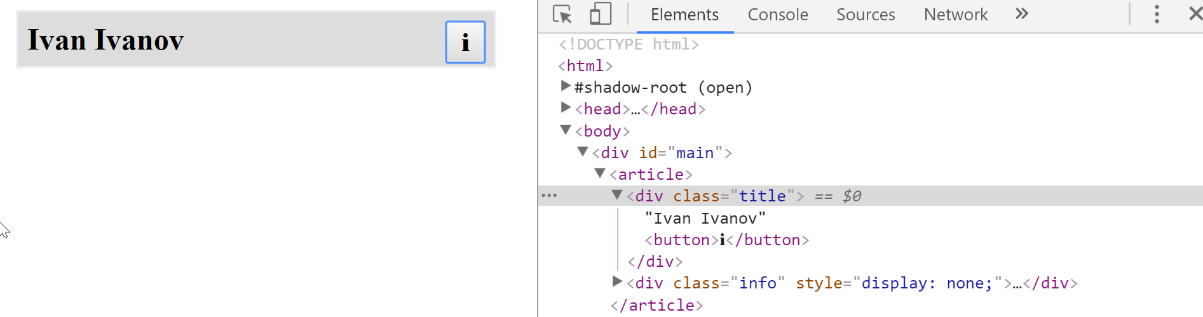
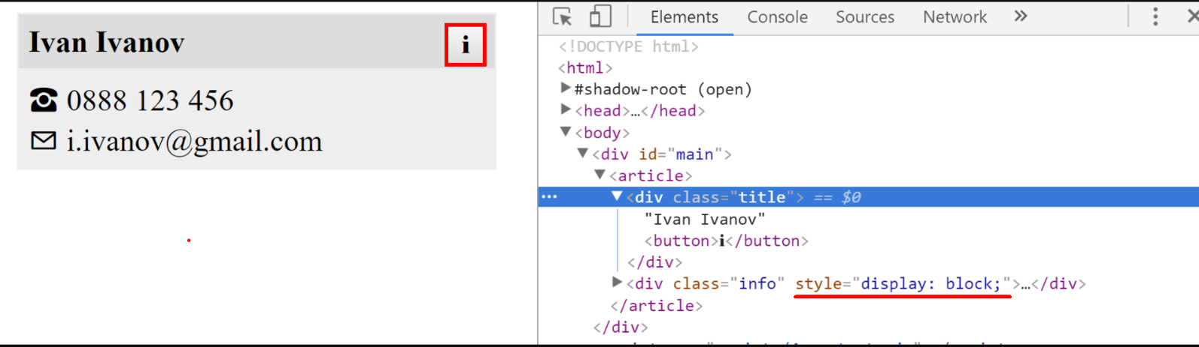
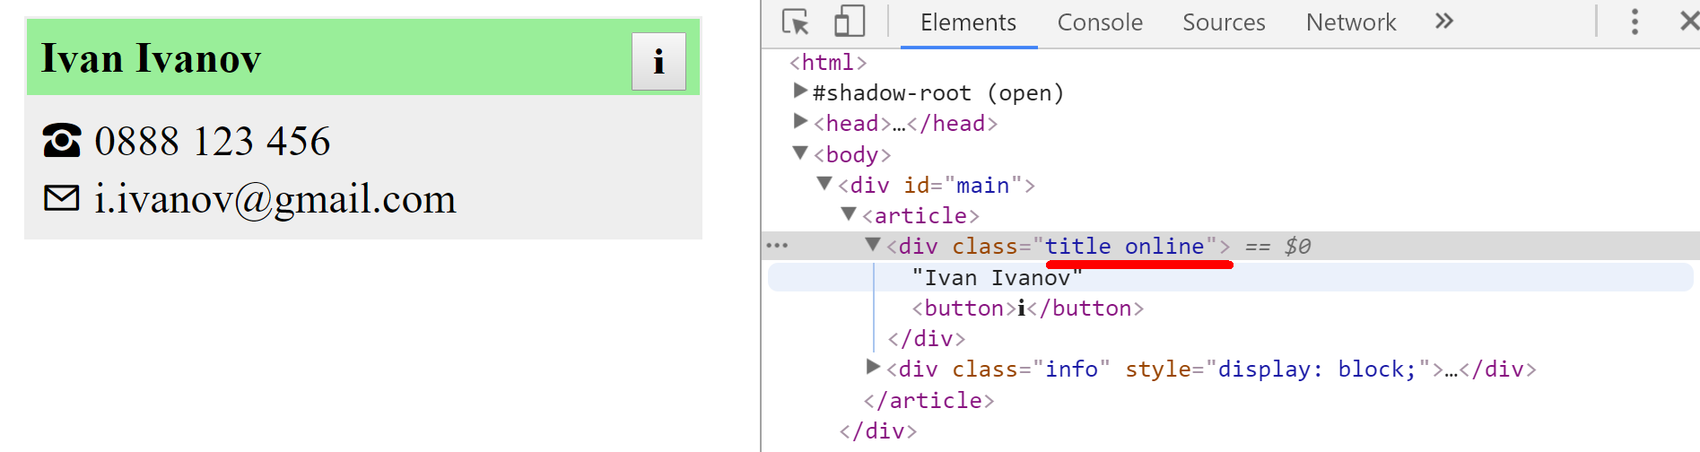

View Model

We need to create a class Textbox that represents one or more HTML input elements with type="text". The constructor takes as parameters a selector and a regex for invalid symbols.
Textbox elements created from the class should have:
- property value (has getters and setters)
- property _elements containing the set of elements matching the selector
- getter elements for the _elements property – return as NodeList
- property _invalidSymbols - a regex used for validating the textbox value
- method isValid() - if the _invalidSymbols regex can be matched in any of the _elements values return false, otherwise, return true.
All _elements values and the value property should be linked. If the value of an element from _elements change all other elements' values and the value property should instantly reflect it, likewise should happen if the value property changes.

Constraints
- Selectors will always point to input elements with type text.

Example
To help you test your code, you're provided with an HTML template.
And an example JS skeleton.
Here is an example output in the browser:
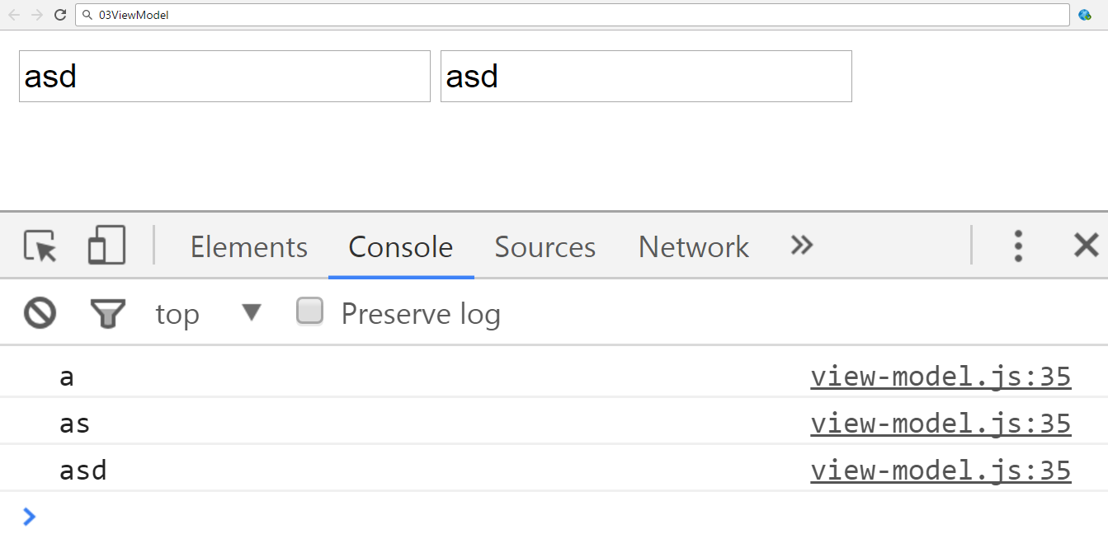
And the isValid function.
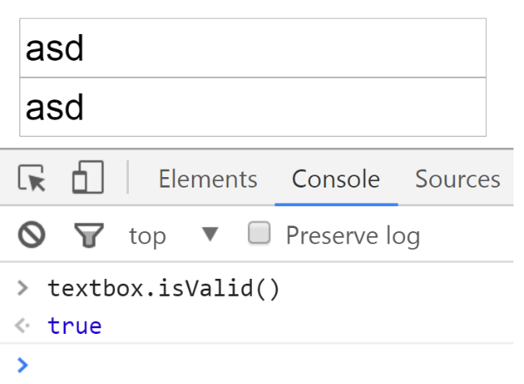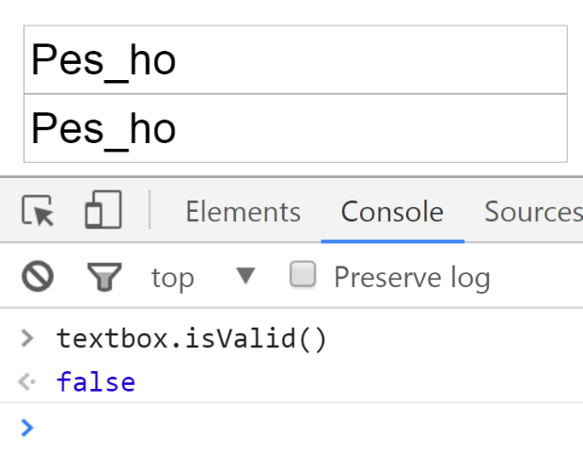
Submit only the Textbox class definition.

Hints
- Pay attention to what event you use, different events trigger on different conditions. You want an event that is directly linked to changes in the value of an input element.
- Pay close attention to the value of this when writing event handler functions.

Unit Testing on Classes

Payment Package
You are given the following JavaScript class:
PaymentPackage.js
class PaymentPackage {
constructor(name, value) {
this.name = name;
this.value = value;
this.VAT = 20; // Default value
this.active = true; // Default value
}
get name() {
return this._name;
}
set name(newValue) {
if (typeof newValue !== 'string') {
throw new Error('Name must be a non-empty string');
}
if (newValue.length === 0) {
throw new Error('Name must be a non-empty string');
}
this._name = newValue;
}
get value() {
return this._value;
}
set value(newValue) {
if (typeof newValue !== 'number') {
throw new Error('Value must be a non-negative number');
}
if (newValue < 0) {
throw new Error('Value must be a non-negative number');
}
this._value = newValue;
}
get VAT() {
return this._VAT;
}
set VAT(newValue) {
if (typeof newValue !== 'number') {
throw new Error('VAT must be a non-negative number');
}
if (newValue < 0) {
throw new Error('VAT must be a non-negative number');
}
this._VAT = newValue;
}
get active() {
return this._active;
}
set active(newValue) {
if (typeof newValue !== 'boolean') {
throw new Error('Active status must be a boolean');
}
this._active = newValue;
}
toString() {
const output = [
`Package: ${this.name}` + (this.active === false ? ' (inactive)' : ''),
`- Value (excl. VAT): ${this.value}`,
`- Value (VAT ${this.VAT}%): ${this.value * (1 + this.VAT / 100)}`
];
return output.join('\n');
}
}

Functionality
The above code defines a class that contains information about a payment package. An instance of the class should support the following operations:
- Can be instantiated with two parameters - a string name and number value
- Accessor name - used to get and set the value of the name
- Accessor value - used to get and set the value of value
- Accessor VAT - used to get and set the value of VAT
- Accessor active - used to get and set the value of active
- Function toString() - return a string, containing an overview of the instance; if the package is not active, append the label "(inactive)" to the printed name
When creating an instance, or changing any of the property values, the parameters are validated. They must follow these rules:
- name - non-empty string
- value - non-negative number
- VAT - non-negative number
- active - Boolean
If any of the requirements aren’t met, the operation must throw an error.
Scroll down for examples and details about submitting to Judge.

Example
This is an example of how this code is intended to be used:
Sample code usage
// Should throw an error
try {
const hrPack = new PaymentPackage('HR Services');
} catch(err) {
console.log('Error: ' + err.message);
}
const packages = [
new PaymentPackage('HR Services', 1500),
new PaymentPackage('Consultation', 800),
new PaymentPackage('Partnership Fee', 7000),
];
console.log(packages.join('\n'));
const wrongPack = new PaymentPackage('Transfer Fee', 100);
// Should throw an error
try {
wrongPack.active = null;
} catch(err) {
console.log('Error: ' + err.message);
}
Corresponding output
Error: Value must be a non-negative number
Package: HR Services
- Value (excl. VAT): 1500
- Value (VAT 20%): 1800
Package: Consultation
- Value (excl. VAT): 800
- Value (VAT 20%): 960
Package: Partnership Fee
- Value (excl. VAT): 7000
- Value (VAT 20%): 8400
Error: Active status must be a boolean

Your Task
Using Mocha and Chai write unit tests to test the entire functionality of the PaymentPackage class. Make sure instances of it have all the required functionality and validation. You may use the following code as a template:
describe("TODO …", function() {
it("TODO …", function() {
// TODO: …
});
// TODO: …
});

